Evaluating the 20-Minute City Concept using Linked Open Data- Case Study: Mashhad Metrpolitan

Nafise Ameri
Faculty of Engineering
Ferdowsi University of Mashhad,
Mashhad, Iran
nafasameri97@gmail.com
Malihe Shahryari
Faculty of Engineering
Ferdowsi University of Mashhad,
Mashhad, Iran
maliheh.shahryari@gmail.co
Samira Zangoei
Faculty of Engineering
Ferdowsi University of Mashhad,
Mashhad, Iran
samirazangoei@yahoo.com
Mohsen Kahani
Faculty of Engineering
Ferdowsi University of Mashhad,
Mashhad, Iran
kahani@um.ac.ir

Abstract— The concept of the 20-Minute City has gained significant attention as a promising approach for evaluating sustainable and livable urban environments. However, accesing the required data for this evaluation can be costy and time-consuming. Linked Open Data (LOD) provides a wealth of information for many areas. This paper investigates the use of LOD for evaluation of the 20-Minute City copcept. As a case study we have used the data and techniques to evaluate this concept for the city of Mashhad. Mashhad in the second largest and populated city of Iran and is located in the north-east of the country. Through the analysis, the index of 75.22 was calculated for Mashhad city, indicating that Mashhad is 75.22% close to being a "20-minute city".
Keywords—20-Minute City; Mashhad; Iran; urban issues; sustainable urban development; case study;

Introduction
Urban areas worldwide are facing significant challenges due to rapid population growth, traffic congestion, and environmental concerns. In the pursuit of sustainability, livability, and inclusivity, a novel concept has emerged - the 20-Minute City. The 20-Minute City is an urban development approach that aims to create compact, self-sufficient neighborhoods where residents can access their daily needs within a 20-minute walk or bike ride from their homes. This paradigm shift in urban planning prioritizes accessibility, connectivity, and proximity to improve the quality of life for urban dwellers [2].
Traditionally, cities have been designed with a focus on segregating land uses, resulting in sprawling neighborhoods heavily reliant on private vehicles. This car-centric approach has led to negative consequences such as increased traffic congestion, air pollution, and decreased social cohesion. Conversely, the 20-Minute City seeks to reshape urban landscapes by fostering mixed-use neighborhoods that integrate residential, commercial, recreational, and educational facilities in close proximity. This proximity enables residents to meet their daily needs and engage in activities without undertaking long and energy-consuming commutes [8, 14, 17].
Moreover, the 20-Minute City promotes active modes of transportation like walking and cycling, reducing reliance on cars and encouraging healthier lifestyles. The concept acknowledges the significance of creating safe and appealing pedestrian and cycling networks that facilitate active mobility. By prioritizing non-motorized transportation and investing in infrastructure such as pedestrian-friendly streets, dedicated bike lanes, and public transportation systems, cities can improve mobility, reduce traffic congestion, and decrease greenhouse gas emissions [1, 6].
This transformative urban planning approach has gained global traction, with cities like Paris, Melbourne, and Barcelona actively adopting and implementing the principles of the 20-Minute City. These cities are reimagining their urban fabric, redesigning public spaces, and investing in sustainable transport infrastructure to cultivate vibrant, walkable neighborhoods. Additionally, technological advancements and data-driven planning tools have played a vital role in facilitating the realization of the 20-Minute City vision by providing insights into mobility patterns, land use optimization, and infrastructure planning [2].
While the 20-Minute City presents potential benefits beyond transportation and urban form, such as enhanced social interaction, local economic promotion, and improved public health outcomes, challenges like land use constraints, funding limitations, and community engagement pose significant obstacles to widespread implementation [6, 8].
This paper aims to explore the key principles and components of the 20-Minute City, examine its potential benefits and challenges, and analyze its evaluation in Mashhad city. By doing so, we seek to provide a comprehensive understanding of the 20-Minute City and contribute to the ongoing discourse on sustainable urban development.
The remainder of the paper is organized as follows. In Section 2, we review related literature. Section 3 introduces the 20-Minute City criteria and analyzes its evaluation in Mashhad city. In Section 4, we propose our quality model. We evaluate the proposed model in Section 5 and conclude in Section 6.

Related Works
The concept of the 20-Minute City has garnered considerable attention in urban planning and sustainable development literature. Scholars and researchers have extensively explored various aspects of this innovative urban design approach, investigating its potential benefits, challenges in evaluation, and presenting case studies of cities that have embraced similar principles. This section provides an overview of the key findings from relevant studies in this field.

Accessibility and Proximity
The core principles of the 20-Minute City revolve around accessibility and proximity. Scholars have emphasized the significance of developing compact, mixed-use neighborhoods where essential amenities and services are easily accessible to residents. By minimizing travel distances, residents are encouraged to use sustainable modes of transportation. For instance, studies by D.C.Da Silva et al. (2020) have demonstrated the positive correlation between neighborhood design with shorter distances and higher rates of active transportation [6].

Multi-modal Transportation
Efficient and sustainable transportation systems play a vital role in realizing the vision of the 20-Minute City. Numerous studies have focused on integrating various transportation modes such as walking, cycling, and public transit. Research by R. Dunning et al. (2021) emphasized the importance of well-connected, multimodal networks in facilitating accessibility and reducing reliance on private vehicles [12].

Land Use Planning
Optimal land use planning is crucial for creating 20-Minute Cities. Scholars have explored strategies to promote mixed land use, compact development, and vibrant public spaces. The work of T. Li et al. (2023) investigated the relationship between land use patterns and transportation choices, underscoring the need for cohesive planning approaches that integrate residential, commercial, and recreational areas [16].

Technology and Data-Driven Solutions
Technological advancements and data-driven planning tools have greatly influenced the development of 20-Minute Cities. Researchers have examined the role of digital platforms, geospatial analysis, and real-time data in informing urban planning decisions. A study by A. Calafiore et al. (2022) highlighted the potential of data-driven modeling and simulation techniques in optimizing transportation networks and enhancing accessibility [1].

Case Studies
Numerous cities worldwide have implemented elements of the 20-Minute City concept, providing valuable insights into successful implementation strategies and outcomes. For example, the research conducted by Loukaitou-Sideris and Eckelman (2022) examined the transformation of Melbourne, Australia into a 20-Minute City through investments in public transport, cycling infrastructure, and the integration of land use planning and transport policies [11].
These related works contribute to the growing body of knowledge on the 20-Minute City, offering theoretical frameworks, empirical evidence, and practical examples to guide urban planners, policymakers, and researchers in realizing sustainable and livable urban environments.

20-Minute City Criteria
The concept of the 20-Minute City encompasses a set of criteria and principles that guide the design and development of urban areas. These criteria aim to create compact, self-sufficient neighborhoods where residents can access essential services and amenities within a 20-minute walk or bike ride.

Criteria Associated with the 20-Minute City:
The following criteria are commonly associated with the 20-Minute City:

Mixed-Use Development: A fundamental criterion of the 20-Minute City is the promotion of mixed-use development. This involves integrating residential, commercial, educational, and recreational facilities within close proximity. Having diverse land uses within a neighborhood reduces the need for long-distance travel and supports the concept of complete communities. Research by Cervero and Kockelman (2020) emphasizes the importance of mixed-use development in facilitating proximity and accessibility [5].

Compact Urban Form: Creating a compact urban form is essential to minimize travel distances and encourage active transportation modes. The design should focus on achieving higher population densities, reducing sprawl, and optimizing land use efficiency. A study by Shamsuddin et al. (2021) discusses the relationship between compact urban form and walkability, highlighting the positive impact on accessibility and reducing reliance on private vehicles [15].

Walkability and Cycling Infrastructure: Walkability and cycling infrastructure are key elements of the 20-Minute City. Pedestrian-friendly streets, well-designed sidewalks, dedicated bike lanes, and bike-sharing programs facilitate active modes of transportation. Researchers such as Handy et al. (2022) have explored the correlation between walkability, cycling infrastructure, and increased walking and cycling rates in urban areas [9].

Public Transportation and Connectivity: Efficient public transportation systems play a vital role in enabling residents to reach destinations beyond the 20-minute walking or cycling radius. Accessible and reliable public transit options, such as buses, trams, or metro networks, enhance connectivity within the city and provide an alternative to private vehicle use. Studies by Vassallo et al. (2023) have examined the integration of public transportation with land use planning to promote accessibility and multi-modal connectivity [19].

Local Service Provision: To create self-sufficient neighborhoods, it is essential to ensure the availability of essential services and amenities within the 20-minute radius. This includes access to grocery stores, healthcare facilities, schools, parks, and recreational spaces. Researchers such as Kim and Ulfarsson (2021) have investigated the relationship between local service provision and travel behavior, emphasizing the importance of proximate access to daily needs.

These criteria serve as guidelines for urban planners and policymakers aiming to transform existing urban areas or design new neighborhoods with the 20-Minute City vision in mind. By adopting these criteria, cities can create more sustainable, accessible, and livable environments that prioritize the well-being and convenience of their residents [10].

Analysis of "The 20-Minute City" in Mashhad City
The concept of the 20-Minute City holds significant potential for urban areas in Iran, particularly in cities like Mashhad that are experiencing rapid population growth, increasing urbanization, and transportation challenges. By examining the application of this concept in Mashhad city, we can gain insights into its feasibility, benefits, and challenges within the local context.

Current Urban Challenges in Mashhad and Iran: Mashhad, as one of the largest cities in Iran, faces numerous urban challenges such as traffic congestion, air pollution, and limited accessibility to essential services. These challenges are not unique to Mashhad but are also prevalent in other Iranian cities. An analysis by V. Vakili et al. (2018) discusses the transportation-related challenges faced by Mashhad and highlights the need for sustainable urban development strategies [18].

Potential Benefits of the 20-Minute City in Mashhad and Iran: Implementing the principles of the 20-Minute City in Mashhad and other Iranian cities can bring about various benefits. It can reduce traffic congestion by encouraging active modes of transportation and reducing reliance on private vehicles. This, in turn, can lead to improvements in air quality and public health. Research by A. Qazimirsaeed et al. (2022) discusses the potential benefits of walkability and the promotion of non-motorized transportation in Iranian cities [4].

Urban Design and Infrastructure Considerations: To realize the vision of the 20-Minute City in Mashhad and other Iranian cities, careful urban design and infrastructure planning are necessary. This includes developing a well-connected network of pedestrian-friendly streets, dedicated cycling lanes, and efficient public transportation systems. A study by E. Jamei et al. (2021) examines the role of urban design in promoting sustainable transportation and accessibility in Iranian cities [7].

Local Context and Cultural Factors: It is essential to consider the local context and cultural factors when applying the 20-Minute City concept in Mashhad and other Iranian cities. Factors such as social norms, urban morphology, and historical heritage should be taken into account. Research by A. Pilehvar (2021) explores the cultural dimensions of urban development in Iran and emphasizes the importance of community engagement and stakeholder involvement [3].

Implementation Challenges and Lessons Learned: While the 20-Minute City concept holds promise, it also poses challenges in implementation. These challenges may include land use constraints, funding limitations, and resistance to change. An analysis of case studies from Mashhad and other Iranian cities can shed light on the implementation challenges and provide valuable lessons learned. A study by S. Amoushahi et al. (2022) examines the barriers to sustainable urban development in Iranian cities and provides insights into overcoming obstacles [13]. By analyzing the application of the 20-Minute City concept in Mashhad city, we can identify opportunities for sustainable urban development, address local challenges, and enhance the livability and accessibility of these urban areas.

Materials and Methods
In this section, we outline the materials and methods employed to retrieve and process data from OpenStreetMap (OSM) for the analysis of the 20-Minute City concept.
In order to access the code for our project, please refer to our source code at GitHub repository. The repository contains the complete implementation of the code, allowing you to explore the details of our 20-minute city concept in Mashhad, Iran.

Data Retrieval from OpenStreetMap
OpenStreetMap (OSM) is a collaborative mapping project that provides detailed geographic data worldwide. To access and analyze specific data within OSM, we utilized the SPARQL query language. Although OSM offers interactive maps and browsing capabilities, extracting and analyzing specific data requires a customized approach.
To retrieve subarea information within the boundary of Mashhad city, we developed a specific SPARQL query. This query targets the Mashhad boundary relation and retrieves relevant data. Each component of the query is explained, and an overview of its functioning is provided.

Division of Districts, Zones, and Neighborhoods in Mashhad City
Mashhad, located in the Razavi Khorasan Province of Iran, has been divided into various administrative units to facilitate governance and urban planning. These divisions include districts, zones, and neighborhoods.

Districts: Mashhad is officially divided into 11 districts, namely the Central District, Ahmadabad, Ahmadabad Mastofi, Asia, Piroozi, Shahid Kaveh, Kowsar, Mohammadabad, Neyshabur, Hemmatabad, and Varamin. District divisions aim to streamline administrative processes and ensure efficient governance and resource allocation across different areas of the city.

Zones: In addition to districts, Mashhad is further classified into different zones based on geographic location and characteristics. These zones include the central zone, north zone, south zone, east zone, and west zone. Zone divisions assist in urban planning, development initiatives, and targeted resource allocation based on the unique requirements and characteristics of each zone.

Neighborhoods: Mashhad comprises numerous neighborhoods that contribute to the city's localized identities and communities. Notable neighborhoods include the city center, Ahmadabad, Ahmadabad Mastofi, Asia, Piroozi, Shahid Kaveh, Kowsar, Mohammadabad, Neyshabur, Hemmatabad, and Varamin. Neighborhood divisions foster a sense of belonging, enable efficient provision of local services, and encourage community engagement and participation in neighborhood-specific initiatives.

Reasons for Division: The division of Mashhad into districts, zones, and neighborhoods serves several purposes. Firstly, it facilitates effective governance and administration by decentralizing decision-making processes, allowing for localized management and tailored service provision. Secondly, it aids in urban planning and development initiatives, as each unit can be assessed and addressed individually, considering specific demographic, economic, and social factors. Furthermore, these divisions promote a sense of community and facilitate civic engagement, as residents can actively participate in neighborhood-specific initiatives and contribute to local development.
In the following sections, we present the retrieval of Mashhad city districts and regions using SPARQL queries on OpenStreetMap data. We then explain the process of obtaining relation boundaries, calculating road lengths, and determining amenity counts within the geographic areas of Mashhad using a Python script.

Finding Regions using SPARQL
Querying OpenStreetMap (OSM) data using SPARQL offers a robust method to extract specific information. In this article, we examined a sample SPARQL query that retrieves subareas within the Mashhad boundary relation. By analyzing each component of the query, we gained an understanding of how it retrieves the names, administrative levels, and coordinates of the subareas, while also considering intermediate relations.

SPARQL query that retrieves subareas within the Mashhad boundary relation.
SELECT * WHERE {
osmrel:5725142 osmm:has+ ?subarea.
?area ?subarea "subarea".
?subarea osmt:name ?name_subarea.
?area osmt:name ?name_area.
?subarea osmm:loc ?coordinates_subarea.
?area osmm:loc ?coordinates_area.
}
ORDER BY ?name_area ?name_subarea
The query begins by specifying the Mashhad boundary relation and retrieves its subareas using the osmm:has+ predicate. By utilizing the osmm:has+ predicate, the query captures not only the immediate subareas but also the subareas nested within intermediate relations.
Next, the query filters the subareas based on their role within any relation. This enables the query to retrieve subareas regardless of whether they are directly linked to the Mashhad relation or nested within other relations.
To gather meaningful information about the subareas, the query extracts their names and the names of their corresponding areas (relations). Additionally, the query obtains the coordinates of the subareas and their parent areas.
To present the results in an organized manner, the query concludes with an ORDER BY clause. The results are sorted first by the name of the area and then by the name of the subarea, ensuring a logical arrangement of the retrieved data.

Data Extraction with Python Script
To extract OSM data for specific relation IDs, we utilized a Python script that leverages the osmpy library and the OSM Overpass API. The script allows us to retrieve data based on relation IDs and provides opportunities for data analysis.
Overpass API: osmpy is a Python library that provides an easy-to-use interface for querying OpenStreetMap data using the Overpass API.
In this paper, we have chosen to use osmpy as our primary tool for data retrieval and analysis. The decision to opt for osmpy is rooted in its seamless integration with the OpenStreetMap platform and its powerful capabilities for querying and processing spatial data. As our project focuses on assessing the alignment of Mashhad with the principles of the 20-Minute City concept, osmpy's spatial querying functionalities enable us to extract relevant information efficiently.
In this section, we walk through the Python script, explaining its functionality step by step. We highlight its ability to extract OSM data, calculate road lengths, and determine amenity counts within the geographic areas of Mashhad using relation IDs.

Extracting and Analyzing OpenStreetMap Data with Python and osmpy
The algorithm to retrieve amenties of each subarea
Call overpass API with each relation id
Get bounding box coordinates from data
Create a polygon from the bounding box coordinates
Print the polygon as a WKT string
RoadLength = osmpy.get('RoadLength', boundary)
AmentiesCount = osmpy.get('AmentiesCount', boundary)

Data Retrieval: We retrieved the necessary data from OpenStreetMap using the Overpass API. The Overpass API allows us to query specific geographic areas and obtain relevant information. The following steps were undertaken:

Defined a list of relation IDs representing the desired geographic areas of interest.

For each relation ID, we constructed an Overpass API query to retrieve the relation data. The query included specifying the output format as JSON and requesting the geometry of the relation.

Data Processing: Once the data was retrieved, we processed it using various libraries and techniques. The following steps were performed:

We parsed the JSON response to extract the relevant information, such as the name of the area and its bounding box coordinates.

To create a polygon representation of the bounding box, we utilized the Shapely library.

The polygon was then converted into a Well-Known Text (WKT) string for further analysis and visualization.

We utilized the osmpy library to work with the OpenStreetMap data and perform specific operations on the defined boundary.

We conducted two main types of analyses on the boundary:

Road Length Calculation: Using the osmpy library, we calculated the length of roads within the boundary.

Amenity Count Calculation: With the help of the osmpy library, we determined the count of amenities within the boundary.

Experimental Setup: The script was executed in a Python environment with the necessary dependencies installed. We used Jupyter Notebook as the development environment, running the script cell by cell.

Data Storage: The resulting data, including the relation boundaries, road lengths, and amenity counts, were stored in CSV file. The files were organized in the following format: [area-name]-[relation-id]-[analysis-type].csv.
The script was executed to obtain relation boundaries, calculate road lengths, and determine amenity counts within specific geographic areas. It empowers users to tap into the wealth of OSM data and gain valuable insights for various domains such as urban planning, transportation analysis, and environmental studies.

Results
This section presents the findings obtained from the analysis of urban amenities and infrastructure across various categories in the city. The analysis was conducted using a script that processed data from CSV files containing information on different amenities and road lengths. The results offer valuable insights into the distribution and accessibility of amenities, which play a crucial role in understanding the overall urban environment and its impact on residents' daily lives.

Methodology
The methodology employed in this study involved analyzing the presence and abundance of various amenities and road lengths throughout the city. The script utilized CSV files containing data on amenities and road lengths, which were processed to extract relevant information. The data were then categorized into different groups based on their functions and significance within the urban landscape.

Categories of Amenities
The analysis considered several categories of amenities, including:
1. Public Transport: This category includes amenities such as bus stations, car-sharing services, parking facilities, and taxi stands, among others. A well-connected and efficient public transport system is essential for enhancing mobility and accessibility within the city.
2. Cycling Infrastructure: This category encompasses amenities such as bicycle parking, bicycle rental services, and dedicated cycleways. Developing a robust cycling infrastructure is crucial for promoting cycling as a means of transportation, which requires safe and convenient facilities for cyclists.
3. Sidewalks: Amenities in this category focus on footways and pedestrian paths, which are vital for creating walkable and pedestrian-friendly streets. Well-designed sidewalks contribute to the overall walkability of the city and encourage active modes of transportation.
4. Residential: This category includes amenities associated with residential areas, ensuring access to essential services and facilities for residents.
5. Public Safety: Amenities such as fire stations and police stations contribute to public safety and security within the city.
6. Commercial: This category comprises amenities such as banks, post offices, and ATMs, which facilitate commercial activities and financial transactions.
7. Educational: Amenities related to education, including schools, universities, and educational institutions, were considered in this category.
8. Recreational: Amenities such as cafes, restaurants, libraries, theaters, and parks fall under this category, providing spaces for leisure, entertainment, and social activities.
9. Stores: Marketplaces and vending machines were included in this category, ensuring access to essential goods and services.
10. Healthcare: Amenities such as clinics, hospitals, pharmacies, and veterinary clinics were considered in this category, ensuring access to healthcare services within the city.

The algorithm to calculate the percentage of the amenties of each subarea as well as the percentage of each category in the Mashhad
Read csv files
Create a list of common amenities for counting
Calculate count for each category and Zone
Calculate percentage for each category and Zone if count >= 1

Calculate count of each category
Calculate percentage for each category if count >= 1

Analysis and Findings
The script processed the data and calculated the abundance of amenities in each category. The results are presented in the form of a DataFrame, which provides insights into the distribution and prevalence of amenities across the city. The DataFrame includes the count of amenities in each category, as well as the percentage representing the proportion of categories with at least one amenity present, as indicated in Table1.
1. Public transport amenities, such as bus stations and parking facilities, were available in 80.63% of the analyzed areas, indicating a reasonably well-developed public transport network within the city.
2. The presence of cycling infrastructure was relatively limited, with only 17.56% of the areas featuring dedicated amenities such as bicycle parking and cycleways. This highlights the need for further investment and development to promote cycling as a sustainable mode of transportation.
3. Sidewalks were widely prevalent, with 97.29% of the areas having well-designed footways and pedestrian paths. This signifies a good level of walkability and pedestrian-friendliness throughout the city.
4. Residential amenities were present in 100.0% of the areas, ensuring access to essential services and facilities for residents.
5. Public safety amenities, including fire stations and police stations, were found in 60.36% of the areas, contributing to the overall safety and security of the city.
6. Commercial amenities, such as banks, post offices, markets, and vending machines, were relatively abundant, with 83.33% of the areas having these facilities available.
7. Educational amenities, including schools and universities, were present in 59.45% of the areas, ensuring access to educational institutions.
8. Recreational amenities, such as cafes, restaurants, and parks, were found in 99.54% of the areas, providing spaces for leisure and social activities.
9. Healthcare amenities, including clinics and hospitals, were present in 78.82% of the areas, ensuring access to healthcare services within the city.
- Dispersion of amenity categories in the city of Mashhad
Category | Metric | Category | Metric
public transport | 80.63 | cycling infrastructure | 17.57
sidewalks | 97.3 | residential | 100.0
public safety | 60.36 | commercial | 83.33
educational | 59.46 | recreational | 99.55
healthcare | 78.83 | whole mashhad | 75.22

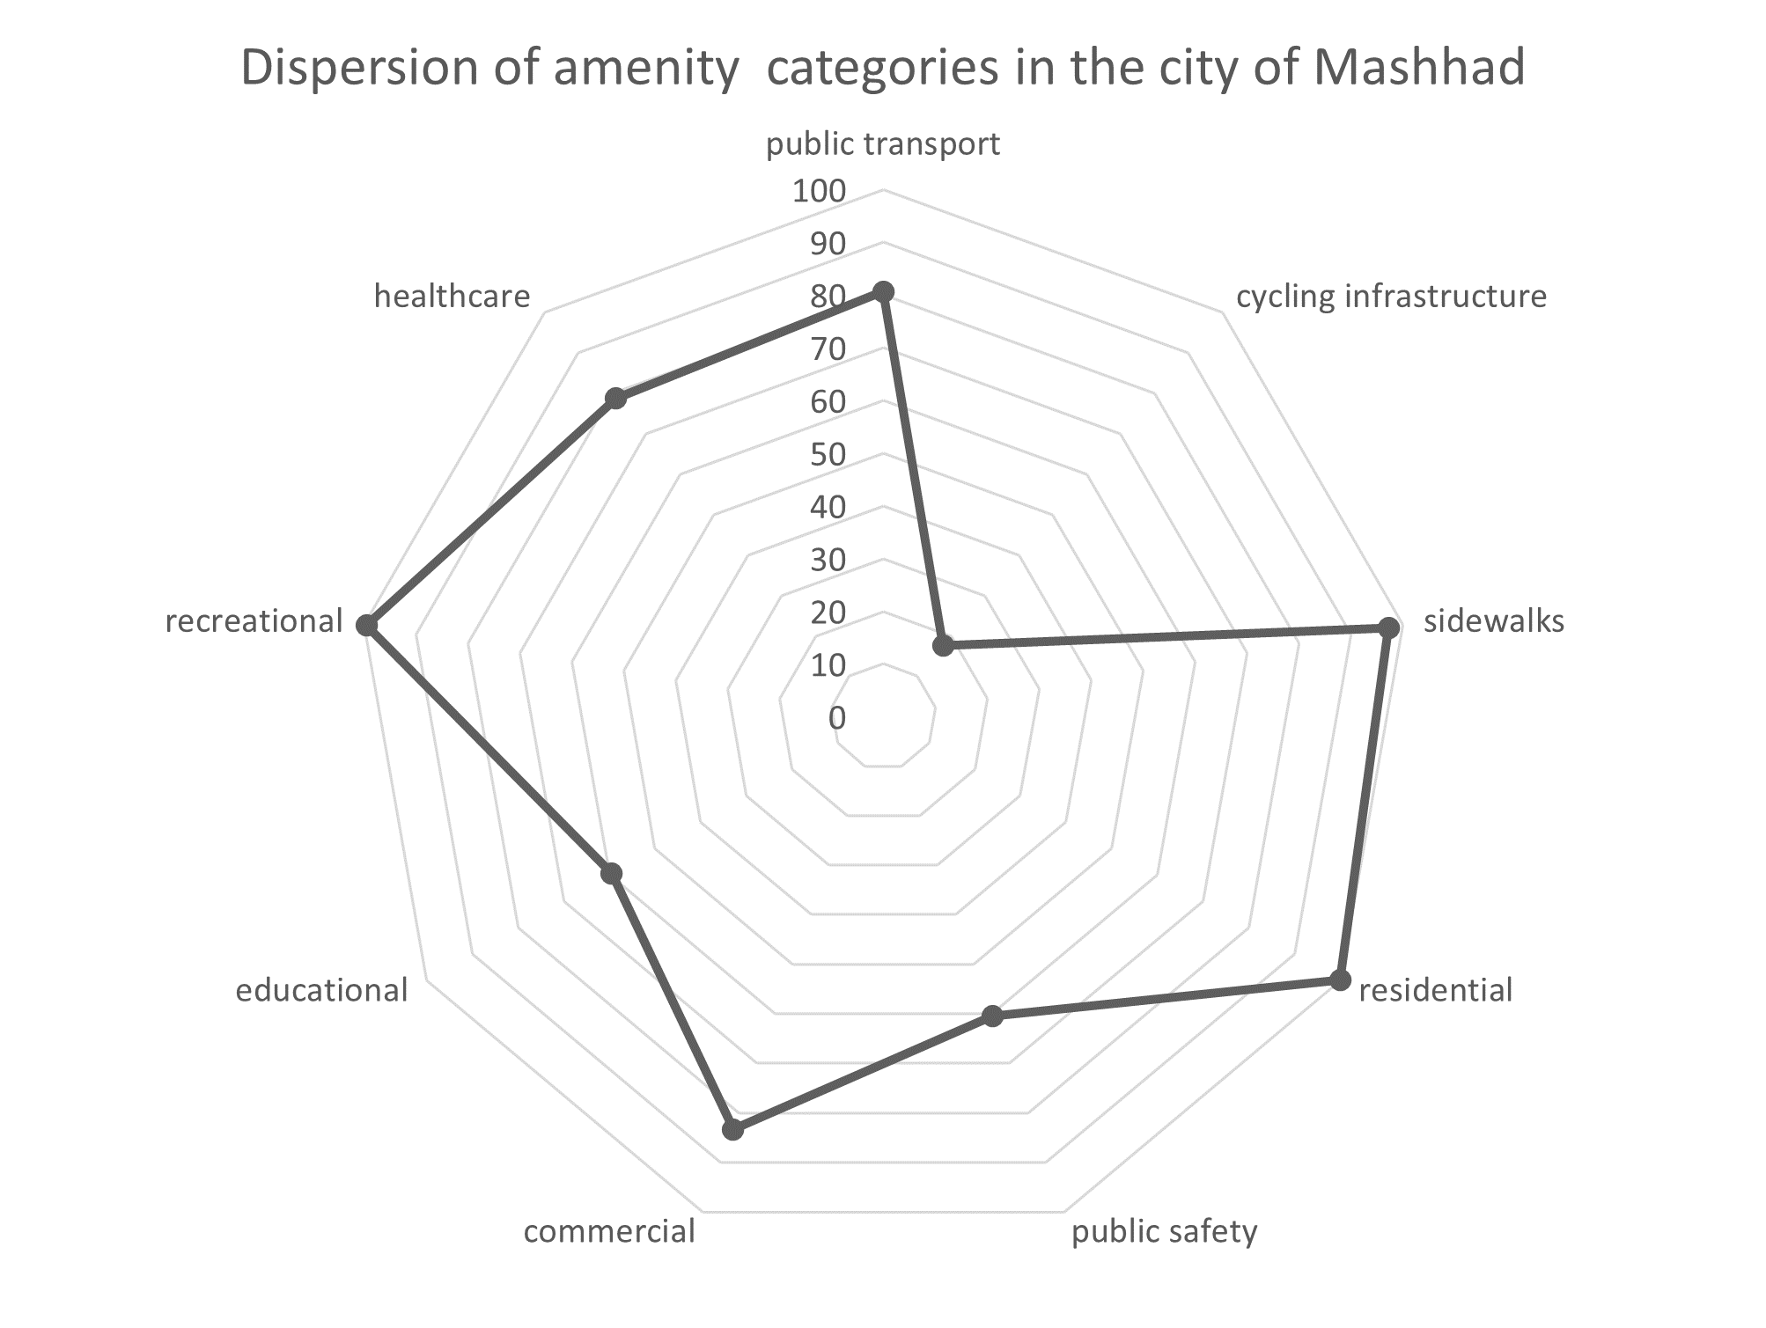
- Dispersion of amenity categories in the city of Mashhad
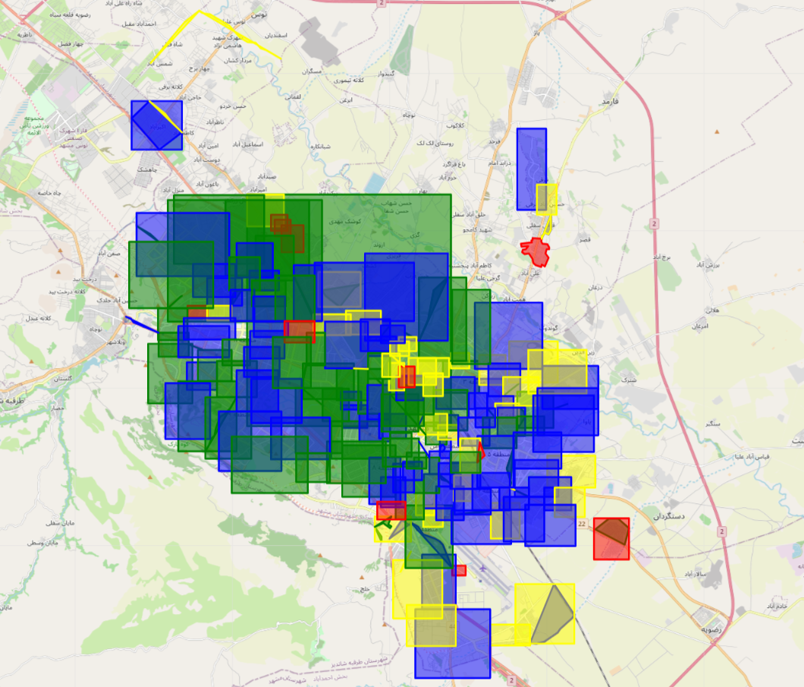
- Map with Colored Polygons: Each polygon represents a geographical area with a color gradient based on the percentage value. Areas with a percentage greater than or equal to 80% are shown in green, those between 60% to 79% in blue, 40% to 59% in yellow, and below 40% in red. The varying colors provide an intuitive visualization of the distribution and concentration of amenity across different regions. As you can see, as we move closer to the upper part of the city, the recreational amenities increase (shown in green), while towards the lower part, they are more in blue or yellow, indicating that the level of amenities ranges from 40% to 80%.

Implications and Recommendations
The analysis of urban amenities and infrastructure provides valuable insights into the livability and quality of life for city residents. The findings shed light on strengths and areas that require improvement in terms of amenity accessibility and distribution across different categories.
Based on the results, the following recommendations can be made:
1. Prioritize further investment and development in cycling infrastructure to promote it as a sustainable mode of transportation. This includes expanding bicycle parking facilities and creating dedicated cycleways.
2. Make efforts to improve and maintain the existing public transport network, ensuring connectivity and accessibility for residents.
3. Give priority to the development of walkable streets and pedestrian-friendly infrastructure to encourage active modes of transportation and enhance walkability throughout the city.
4. Ensure the provision of residential amenities and essential services in all areas to meet the needs of residents.
5. Continue investing in public safety amenities to maintain a secure and safe urban environment.
6. Assess the availability of commercial amenities and take steps to fill any gaps in service provision.
7. Ensure access to educational institutions across all areas of the city, providing equal opportunities for education.
8. Develop and maintain recreational amenities, which are essential for promoting social interaction and improving residents' overall quality of life.
9. Ensure adequate provision of healthcare amenities to guarantee access to healthcare services and promote residents' well-being.
These recommendations can guide urban planners, policymakers, and city authorities in making informed decisions to enhance the urban environment and improve residents' quality of life.

Conclusion
The analysis of urban amenities and infrastructure provides valuable insights into the distribution and accessibility of amenities within the city. The script used in this study processed data from CSV files and categorized amenities into different groups based on their functions and significance. The results highlight both strengths and areas that require improvement in terms of amenities and infrastructure in the city.
By understanding the distribution and prevalence of various amenities, policymakers and urban planners can make informed decisions to enhance the livability and quality of life for residents. The recommendations derived from the analysis can guide future urban development strategies and initiatives, ensuring the provision of essential amenities and promoting sustainable and inclusive urban environments.

References
- A. Calafiore, R. Dunning, A. Nurse, A. Singleton. The 20-minute city: An equity analysis of Liverpool City Region. Transportation Research Part D 102 (2022) 103111.
- A. Gower, C. Grodach. Planning Innovation or City Branding? Exploring How Cities Operationalise the 20-Minute Neighbourhood Concept. Urban Policy and Research. Volume 40, 2022 - Issue 1. https://doi.org/10.1080/08111146.2021.2019701.
- A. Pilehvar. Spatial-geographical analysis of urbanization in Iran. Humanities and Social Sciences Communications volume 8, Article number: 63 (2021).
- A. Qazimirsaeed, H. Khosravi, M. Rafieian, H. Mirzahossein, C. Forciniti. Walkability Policies in Developing Countries: What Do People Need and Prefer in Iran?. Sustainability 2022, 14(17), 10808; https://doi.org/10.3390/su141710808.
- Cervero, Robert, and Kara M. Kockelman. "Travel Demand and the 3Ds: Density, Diversity, and Design." Transportation Research Part D: Transport and Environment, vol. 77, 2020, doi:10.1016/j.trd.2019.102203.
- D. C. Da Silva, D. A. King, S. Lemar. Accessibility in Practice: 20-Minute City as a Sustainability Planning Goal. Sustainability 2020, 12, 129; doi:10.3390/su12010129.
- E. Jamei, K. Ahmadi, H. W. Chau, M. Seyedmahmoudian, B. Horan, A. Stojcevski. Urban Design and Walkability: Lessons Learnt from Iranian Traditional Cities. Sustainability 2021, 13(10), 5731; https://doi.org/10.3390/su13105731.
- F. Shatu , Md. Kamruzzaman. Determining Optimum Design Density for 20-minute Neighbourhoods. TRANSPORT FINDINGS. August 2021. https://doi.org/10.32866/001c.27391.
- Handy, Susan, et al. "What Makes a Neighborhood Walkable? A Literature Review." Journal of Urban Design, vol. 27, no. 1, 2022, pp. 69-90, doi:10.1080/13574809.2021.1961406.
- Kim, Inhi, and Gudmundur Ulfarsson. "Local Accessibility and Travel Behavior: A Study of the 20-Minute Neighborhood Concept." Transportation Research Part A: Policy and Practice, vol. 146, 2021, doi:10.1016/j.tra.2021.07.005.
- Loukaitou-Sideris, Anastasia, and Rachel Eckelman. "Bicycle Infrastructure, Cycling, and the Transformation of Melbourne into a 20-Minute City." Transportation Research Part A: Policy and Practice, vol. 160, 2022, doi:10.1016/j.tra.2022.11.
- R., Dunning, A., Calafiore, A., Nurse, 2021. 20-minute neighbourhood or 15-minute city? J. Town Country Plan. Association, 90, 5/6, 157-159.
- S. Amoushahi, A. Salmanmahiny, H. Moradi, A. R. Mikaeili Tabrizi, C. Galán. Localizing sustainable urban development (SUD): Application of an FDM AHP approach for prioritizing urban sustainability indicators in Iran provinces. Sustainable Cities and Society. Volume 77, February 2022, 103592.
- S. Hernandez, J.M. Miralles i Garcia. The Sustainable City XVI. Publisher: WIT Press, 2022. ISBN: 1784664812, 9781784664817.
- Shamsuddin, Shuhana, et al. "Assessing the Walkability of Compact Cities: A Review of Methods and Criteria." Sustainable Cities and Society, vol. 73, 2021, doi:10.1016/j.scs.2021.103153.
- T. Li, A. Kent, J. Dodson, S. Yina. How Workable is a 20-Minute City in Australia? Re-Examining the Challenge of Change in Spatial Labour and Job Relations. 17 Apr 2023. available at: https://ssrn.com/abstract=4421132.
- T.M. Logan, M.H. Hobbs, L.C. Conrow, N.L. Reid, R.A. Young, M.J. Anderson. The x-minute city: Measuring the 10, 15, 20-minute city and an evaluation of its use for sustainable urban design. Cities 131 (2022) 103924.
- V. Vakili, A. R. Zarifian, M. Khadem-Rezaiyan. Predictors of public transportation in Mashhad: A population-based study. J Educ Health Promot. 2018. doi:10.4103/jehp.jehp_44_17.
- Vassallo, José Manuel, et al. "Public Transport Integration in the 20-Minute City Concept: A Review and Analysis." Transport Reviews, vol. 43, no. 4, 2023, pp. 416-437, doi:10.1080/01441647.2021.1950802.

